**DAILY ONLINE ACTIVITIES SUMMARY**

|  |  |  |  |  |  |  |  |  |
| --- | --- | --- | --- | --- | --- | --- | --- | --- |
| **Date:** | **20-07-2020** | | | | | **Name:** | **Anix Jugal D’Cunha** | |
| **Sem & Sec** | **8 sem , A sec** | | | | | **USN:** | **4AL16CS013** | |
| **Online Test Summary** | | | | | | | | |
| **Subject** | | **Not Conducted** | | | | | | |
| **Max. Marks** | | **--** | | **Score** | | | **--** | |
| **Certification Course Summary** | | | | | | | | |
| **Course** | CSS beginner Easy way to Get started with better web design | | | | | | | |
| **Certificate Provider** | | | **Udemy** | | **Duration** | | | 1hr 16min |
| **Coding Challenges** | | | | | | | | |
| **Problem Statement:** Java program to calculate Discount. | | | | | | | | |
| **Status: Competed** | | | | | | | | |
| **Uploaded the report in Github** | | | | | **yes** | | | |
| **If yes Repository name** | | | | | **alvas-education-foundation/dcunhaanixjugal** | | | |
| **Uploaded the report in slack** | | | | | **yes** | | | |

Online Test Details: (Attach the snapshot and briefly write the report for the same)

**Not Conducted**

Certification Course Details: (Attach the snapshot and briefly write the report for the same)

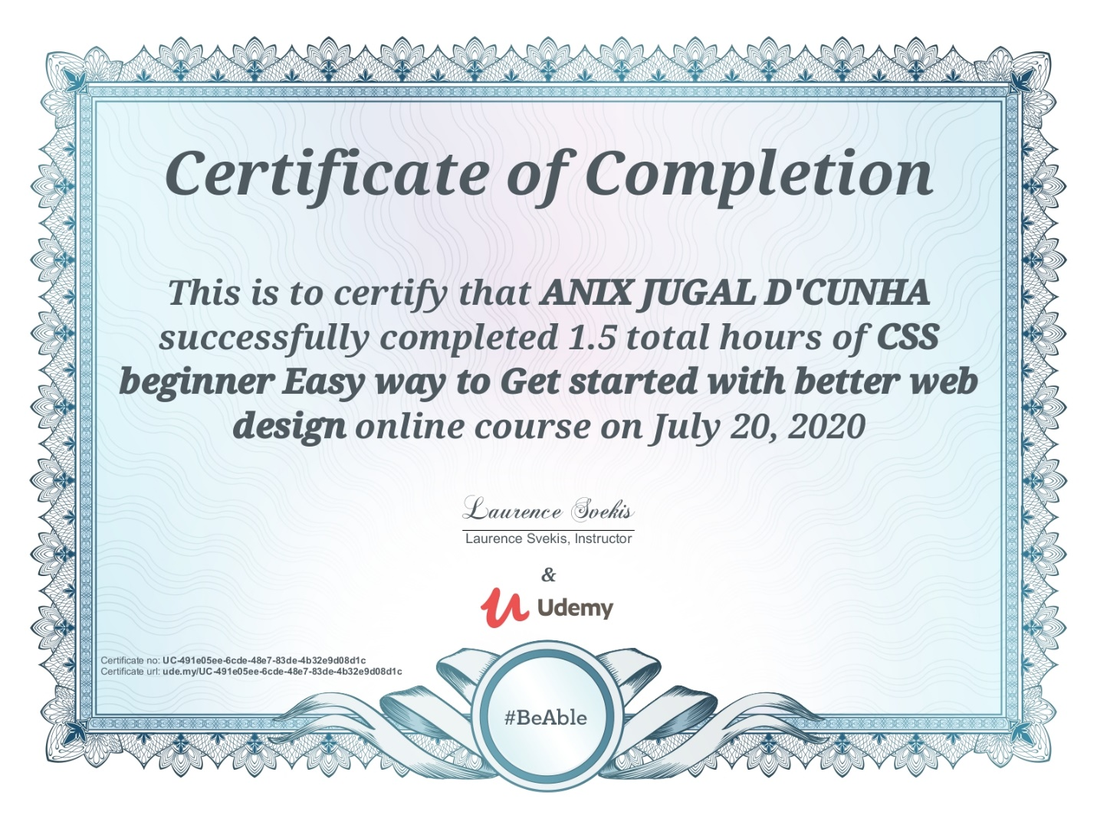

Coding Challenges Details: (Attach the snapshot and briefly write the report for the same)

## Program-> Java program to calculate Discount.

|  |
| --- |
|  |

**class Discount**

**{**

**public static void main(String args[])**

**{**

**double dis,amount,markedprice,s;**

**Scanner sc=new Scanner(System.in);**

**System.out.println("enter markedprice ");**

**markedprice=sc.nextDouble();**

**System.out.println("enter discount percentage ");**

**dis=sc.nextDouble();**

**s=100-dis;**

**amount= (s*markedprice)/100;**

**System.out.println("amount after discount="+amount);**

**}**

**}**

**Output:**

**enter marked price**

**2000**

**enter discount percentage**

**30**

**amount after discount=1400.0**